Babies-Preschool  We invite families with children from birth to preschool to be part of our worship in the Sanctuary! But if desired, a Family Room with age-appropriate toys and a screen to hear & view the service is also available. This room is located near the Women’s Restroom. Changing tables available in both Restrooms. | Kidz’ Church  Children grades K-6th are invited to participate in our Kidz’ Church during our 10:30 AM Worship service. Please register or check in if registered at the Registration Table in the Foyer. Following our offering, children will be dismissed to Bld. C with background-checked volunteers to learn about God’s Word! | Welcome to First Baptist Church  – Mary Esther!  We are excited that you have chosen  to worship with us today! | FBCME Children & Family Ministry  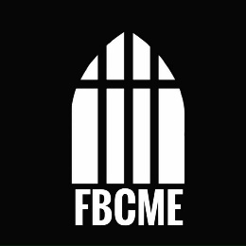
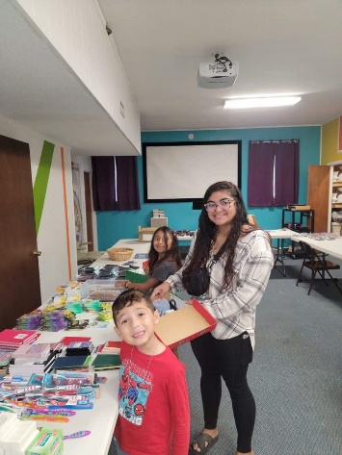  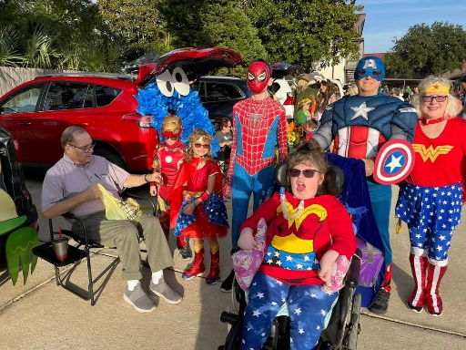 | Special Events  FBCME hosts special events throughout the year for all ages: Parents’ Night Out, Vacation Bible School, Fall Festival, Operation Christmas Child Box packing, participation in Easter & Christmas Worship events, and Christmas parties. | 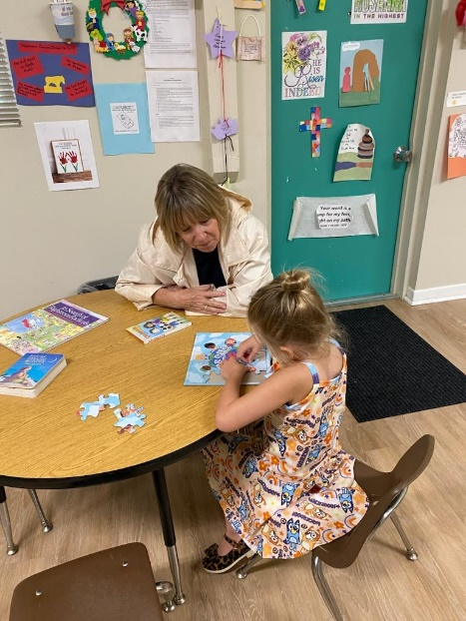 | 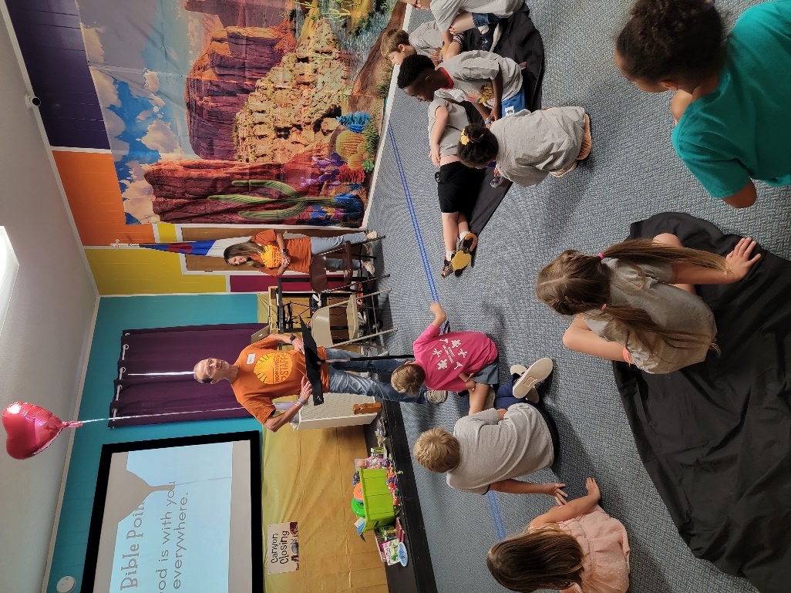
 | 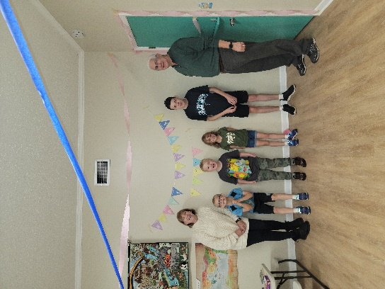 | First Baptist Church  -Mary Esther FL  •••  28 North St  •••  850-243-8300  •••  admin@  fbcme.gccoxmail.com  •••  Fbcme.org

Kids’ Sunday School  Sundays 9:15AM to 10:10AM, children grades K-6th are invited to take part in small group study. We are currently studying the life of our Savior, Jesus!  Join us in Bldg. C, where you find the Kidz’ Church signs. Ring the doorbell for entry. Students will be escorted to Sanctuary to meet parents / guardians. | Why FBCME Children & Family Ministry?  1. Our ministry’s focus is to make disciples by sharing the Gospel.  2. We take our responsibility to your children seriously by requiring all children & student volunteers to be background checked & receive regular training.  3. We seek to partner with parents / guardians to disciple your families by providing age-appropriate tools & training. | Our Mission:  To help make disciples of the next generation.  Our Vision:  To help children, students, and families to Experience God’s love & share His love with others.  Our Prayer:  We desire for each child/student to experience a saving relationship with Jesus Christ. We also value your children’s/student’s relationships within their family, with their church family, and with each other. |  | 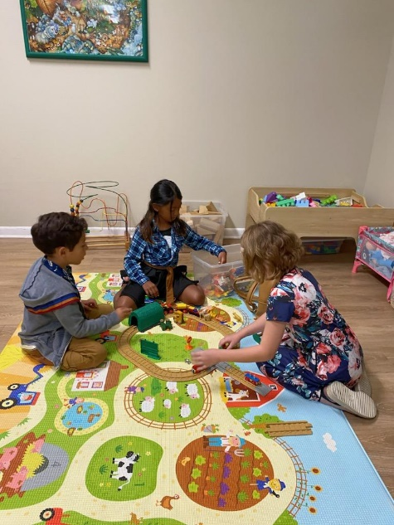
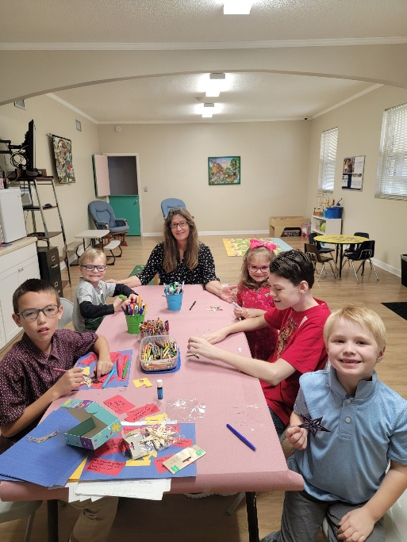 | Youth Sunday School  Sundays 9:15AM to 10:10AM, students grades 7th-12th are invited for small group study in Bld. A (same as adult small groups).  We are currently following the Gospel Project Youth studies. But we will be transitioning to Bible-in-Life starting Feb. 1, 2024. | 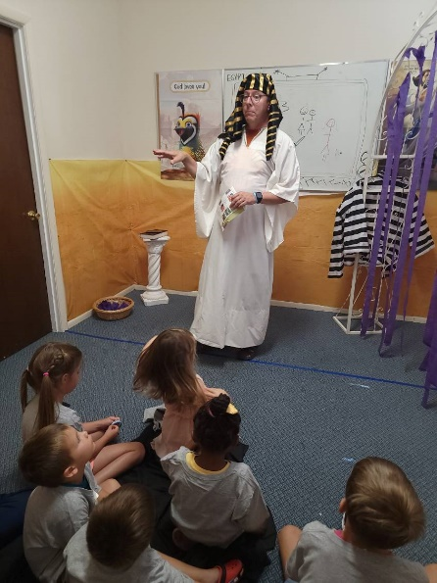 |  | “Oh, that their hearts would be inclined to fear me and keep all my commands always, so that it might go well with them and their children forever.  -Deuteronomy 5:29
 | 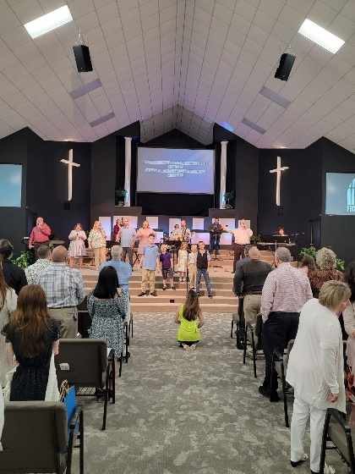 |  | Marriage Classes in 2024  Every marriage needs a “tune-up!” We are inviting 15 couples to participate in the “Best Marriage Ever” Couples Seminar in the Spring Semester Fridays 6-8:30 pm from Feb. 2-Mar. 15. Free Pizza dinner & Kid Care available. Call 850-243-8300 #1 to register. | 